You want to learn chords to play music
- Kinesthetic -How to learn fast and perfectly the first time
- Why learn chords? To make music/ Why music: for emotions/sensations/impressions. Both the mechanical ( chord learning/passing, and the emotional rewards of musical experience are body-dependent. How to condition nerves/muscle apparatus to make music? How to condition ourselves to feel music? Both address the body ( phyiscal) nad the Body-Mind ( psychological, poetic, even spiritual)
List two list

Adult learner Dismantle negative beliefs: Sports coach. If you think you can't, you are right. If you think you cant you are also right.
Nyamas of Yengar yoga: Honesty and non- violence. Dont work the body, Work With the body ,

Dealing with pain/discomfort: Qgong: 1) accept the discomfort 2) welcome it 3) be curious >dialog 4) transformation into heat/energy> Breakthrough smile> the comfort Zone has been expanded into the next level.

Didg. Provoke Synesthesia.!

Show J guita scientist. Diagram Single App Ear training
( The 3rd EAR, or Inner Ear
- play and see note on guitar neck APP
- Remember it, hear it inside with the inner , 3rd , Close eyes, (visualize fret or not???TBC) twice
- Sing that memory
4) Double check
5) celebrate the power of the Inner ear. You just wired your brain for sound.

PArt II : Vocals for guitarists

When you learn a intervals, or a series, or a chord, Allow IMPRESSIONS to be made. We are in the business of making/expressing emotions. Lets start right away! You want to be happy? Start NOw/ Wanna make music? Start now. Plat that interval as if it is EH most Beautiful thing EVAH! Manifest Now.
- BE (at source 2)DO practice 3) HAVE the breakthroughs

Async assessor.???

preserve the safety of
your practice nook here
in Maine?"

AI CO teacher. I don’t feel good about it. There are no wrong note, only an opportunity. Or an unexpected flavor. Expectation create judgement. The worng note is just a note, but in the wrong conetx. In the right context that note can be sublime, even within the same sentence it appeared in when perceived as wrong. It is the expectation that creates the judgment
( Kid playing a blue note in a MAj penta: Chloe: wow waht it that?)

The Voice Octave &
French????

My GUITAR ZEN Drawing in Korean INK

Beginners: Start well, build lifelong good habits
Start simple but grow a complete, wholesome practice from the start!
——-easiest chord shape is found in E : Let's dive in the E universe 1- E minor 7 1 finger!!! : move that 1 finger down a string, same fret, back up. Lets strum, lets finger-style, lets finger-strum)

2- E minor! 2 fingers move those 2 fingers down a string, same fret, back up. Let’s strum,

3- E major, 3 fingers! 3 fingers move those 2 fingers down a string, same fret, back up. Let's strum,

Intermediate: Question your habits, recondition the body, ID bad habits.
What is the most diff? Hurdles? Memorization?
Advanced: rediscover the basics, ID & consolidate what it is that you are doing right.
But avoid overthinking:
BE>DO> HAVE
Be the Music> Do what musicians do> Have the skills musicians have
BE: FEEL: Finger touch, ( Fretting hand’s job Vs Striking Hand)
Hear: Buzzes, loudness, tone, timber, attack, sustain
Rhythm: is a Hear/feel thing:(FHeal) Rhythm is Body English, Soma language physical. You don’t need to understand rhythm to dance. The body feels the Score
Improvise: Get out of the way, and play without Judgement, expectations, premeditation, only meditation. Meditation without premeditation.
Proclaim yourself a Musician: You are now At Source.

Q gong Tai chi. Visualize, Wim Hof Practice less but better. Michael Jordanize!

DO: How to practice like the musician that you are: The 5 Pillars 5 directions
Theory<> fretboard logic<>Hear training<>Body Mechanics<> PERFORMANCE Kinesthesis of healthy, efficient technique

Theory | Fretboard logic | Hear training | Body Mechanics | PERFORMANCE
Western Harmony | String relationships, | Name that tune ( 1-444, Saints) | Do Body+ Instrument Holding/releasing | Be: Know thyself:  Triggers/nerves
C scale/white keys  ID interval formulas | Map 5 1rst frets | Play the numbers | Protocol #1: Gimme a buzz Proper Fretting | Know thy music  memorize
Triads first! Leading towards…. | PLING Melodic hear Playing HearSeePlayFeel the Basic CAGED Triad Shapes  PLING | PLING Melodic hear Singing > HearSeePlayFeel the Basic CAGED Triad Shapes  PLING | Protocol #2: Finger-style Pluck& release | Know thy Heart “Emotional Loading” of the piece
Pentatonic > | UNCAGE ! Add 6, & 2 to sing 1 2 3 5 6 | UNCAGE ! Add 6, & 2 to sing 1 2 3 5 6 | Rest vs. Free Stroke | Be the Music. Somatize the piece> full down load
Full scales Maps  Vertiscales, and across scales  Basic Types | UNCAGE ! Add 4 & 7 , introducing 1/2 steps for a full Majore scale | UNCAGE ! Add 4 & 7 , introducing 1/2 steps for a full Majore scale | Stretching the FASCIA …Also Inner connections meditations | Open mic prep.  Cardio/voice warm up/
Building fresh Chords from scratch together:  Intro to Diatonic chord series ( see proprietary worksheet* to build your own chords from scratch, so you OWN them from the ground up!) | MAPS See and Building fresh Chords from scratch together: | PLING the chords,  Playing: invent easy melodies with easy flavorings : 2nd, 4th 6th  Have: Musicianship | Simple chord transformations:  One finger move  Two finger moves  Chord passing:  SILENT PROTOCOL | Performance 3x without 1 mistake.  Practice/performe before bed> best for neuropathways> Visualize perfect easy stage performance before sleep.( FHEAL it!)
Forget all of the Above | “Random” playing  Geometric Coherence= Musical coherence | Fhearl first, play second  Exist FASTER than premeditation and Judgment  Fheal a story, or atmoshpere and play to it | Wide Open body-mind conduit  Improv’ games | Creativity Coaching: Expression , fearlessness, what is Authenticity? Cultivate emotional honesty.

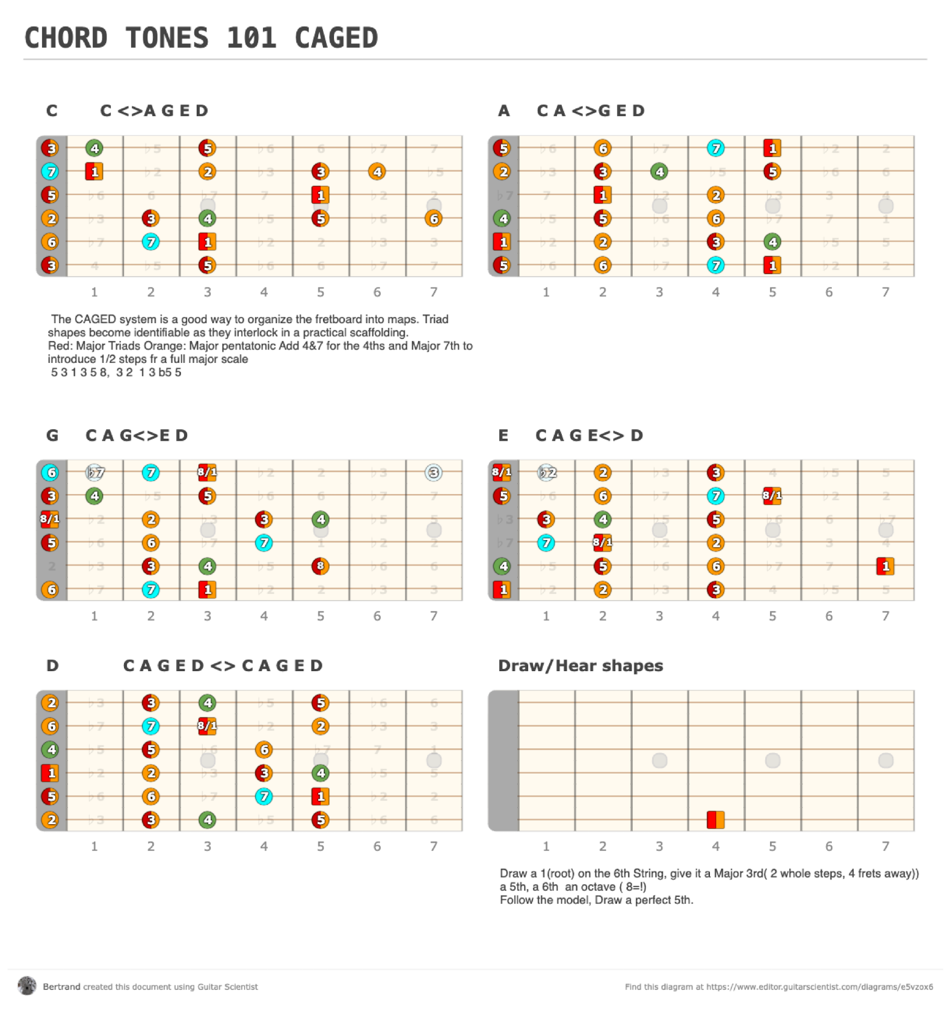

Old text:

My orientation questionnaire ( usually for private lessons) PS In the meantime, here is a little "exercise" I ask of all: could you email me two playlists
with, if possible, actual titles of the songs or compositions?

1) The Past: the music you grew up with-not necessarily your favorite- but music that marked the chapters of your life.
No rush. A memory will trigger another. What is your earliest musical memory > What did each of your family members listen to?

2) The Futur: The music you really want to play- in your wildest dreams- by order of priority if possible.

3) The present You Now. Where are you at? how do you see the role and function of the Guitar in your life?

The two lists may overlap-or not, though I recommend learning all chapter-marking music regardless of taste, since it is already part of your memory & “DNA”. This is a great process for both of us. I get a clear idea of your unique musical profile and desires.
Your unique library of past and future references is a fertile ground for creative teaching.
It will facilitate the creation of custom-made exercises just for you.

